Task 1.1
Booth start=[0. 0.] CCD→[1.00000169 2.99999858], f=5.17e-12 iter=33
Booth start=[0. 0.] CCD+Accel→[0.99996217 3.00003966], f=3.02e-09 iter=12
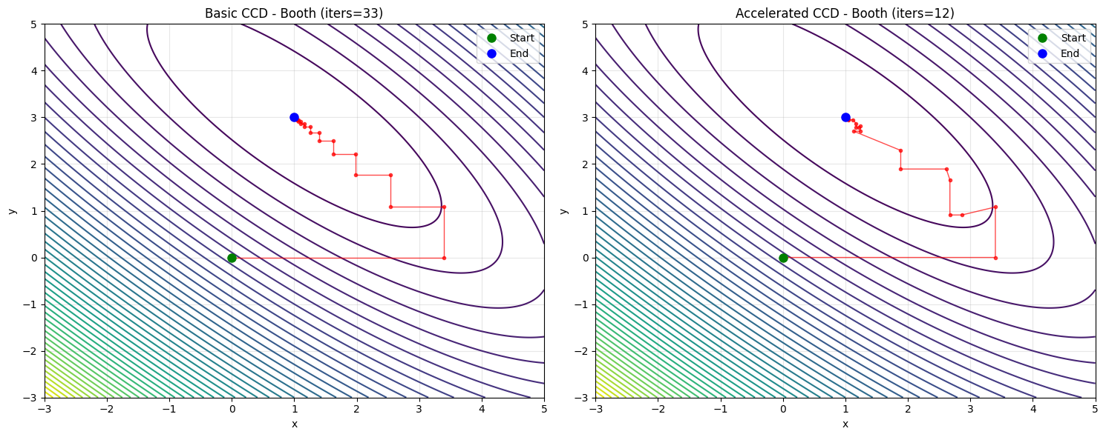
Booth start=[-3. 4.] CCD→[0.99999886 3.00000103], f=2.43e-12 iter=31
Booth start=[-3. 4.] CCD+Accel→[1.00020571 2.99981627], f=7.80e-08 iter=10
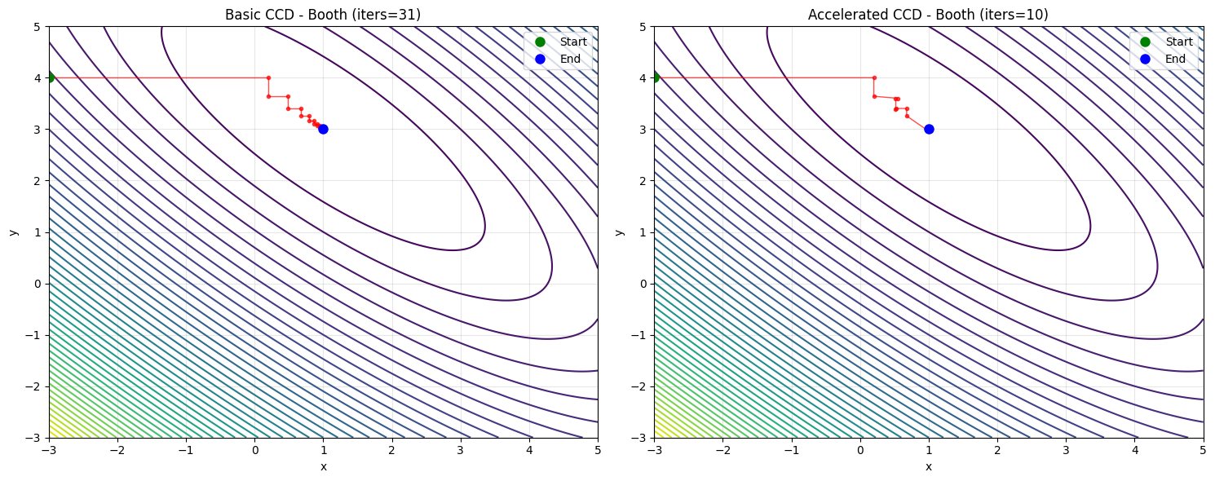

Rosenbrock start=[-1.5 2. ] CCD→[1.00001056 1.00002122], f=1.12e-10 iter=222
Rosenbrock start=[-1.5 2. ] CCD+Accel→[1.0006156 1.00123426], f=3.79e-07 iter=15
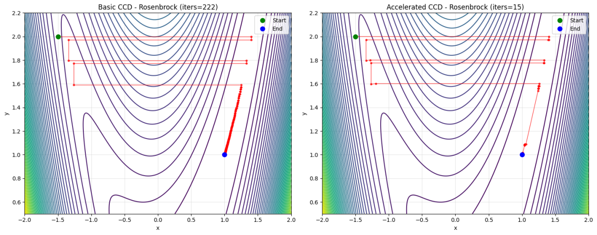
Rosenbrock start=[ 2. -1.] CCD→[0.99998986 0.99997966], f=1.03e-10 iter=206
Rosenbrock start=[ 2. -1.] CCD+Accel→[1.00027524 1.00057411], f=7.85e-08 iter=15
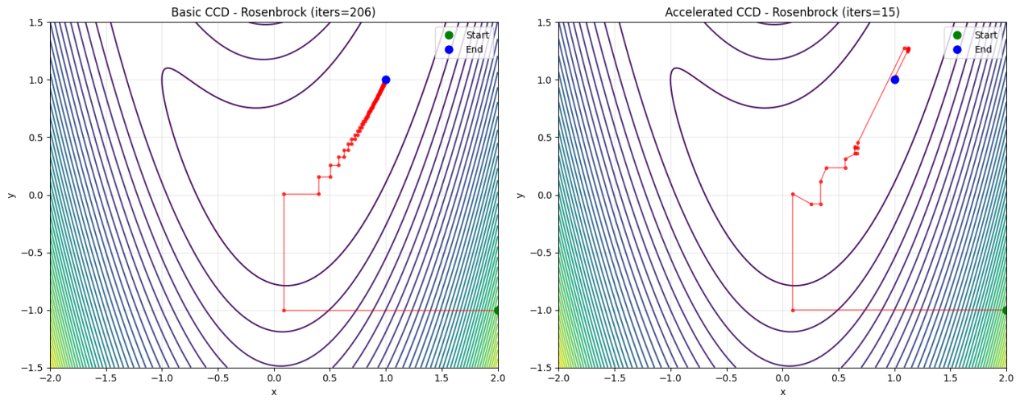
Pathological start=[2. 2.] CCD→[-0.86932356 0.5782595 ], f=1.85e-01 iter=10000
Pathological start=[2. 2.] CCD+Accel→[ 0.28982789 -0.58145288], f=-5.43e-01 iter=3

Pathological start=[-2. -2.] CCD→[-0.86932389 -0.57825994], f=1.85e-01 iter=10000
Pathological start=[-2. -2.] CCD+Accel→[0.28842374 0.58285201], f=-5.43e-01 iter=3

Summary
The function Booth and Rosenbrock converge to the global minimum, while the Pathological function will not converge in general. In the basic CCD method, the function value oscillates back and forth between a finite number of points.
The accelerate step works when the procedure runs close to the minimum, which take much less iterations to reach the demand of the tolerance error.

